Cote d’Ivoire

## Political Stability Estimate Data

The data set shows the political stability estimate of the country each year.

## # A tibble: 19 x 5  
## country iso3c date stability stabilityCategory4   
## <chr> <chr> <dbl> <dbl> <chr>   
## 1 Cote d'Ivoire CIV 1996 0.0348 moderately stable   
## 2 Cote d'Ivoire CIV 1998 -0.202 moderately unstable  
## 3 Cote d'Ivoire CIV 2000 -1.24 highly unstable   
## 4 Cote d'Ivoire CIV 2002 -1.92 highly unstable   
## 5 Cote d'Ivoire CIV 2003 -1.80 highly unstable   
## 6 Cote d'Ivoire CIV 2004 -2.12 highly unstable   
## 7 Cote d'Ivoire CIV 2005 -2.26 highly unstable   
## 8 Cote d'Ivoire CIV 2006 -1.87 highly unstable   
## 9 Cote d'Ivoire CIV 2007 -1.84 highly unstable   
## 10 Cote d'Ivoire CIV 2008 -1.81 highly unstable   
## 11 Cote d'Ivoire CIV 2009 -1.32 highly unstable   
## 12 Cote d'Ivoire CIV 2010 -1.58 highly unstable   
## 13 Cote d'Ivoire CIV 2011 -1.41 highly unstable   
## 14 Cote d'Ivoire CIV 2012 -1.26 highly unstable   
## 15 Cote d'Ivoire CIV 2013 -1.05 highly unstable   
## 16 Cote d'Ivoire CIV 2014 -1.04 highly unstable   
## 17 Cote d'Ivoire CIV 2015 -0.833 moderately unstable  
## 18 Cote d'Ivoire CIV 2016 -0.908 moderately unstable  
## 19 Cote d'Ivoire CIV 2017 -1.09 highly unstable

## Political Stability Estimate Plot

The plot shows the trends of stabilization and destabilization for the each country.

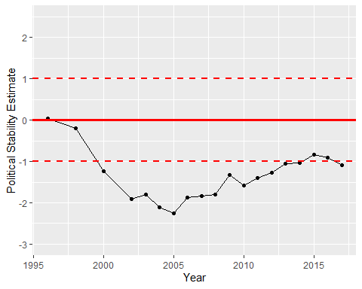

Political Stability Trend